Project Title: E-commerce Website

Overview of the Project:
Designed and developed a full-featured e-commerce website with Django, powered by PostgreSQL. The users can smoothly navigate around the site, create listings for their products, manage user carts, user accounts, and go through secure checkout. The responsive UI is neat and will keep users engaged on different devices.

Technologies Used:
- Backend:
- Django: A Python-based web framework for constructing server-side logic and handling user requests.
- PostgreSQL: relational database for storing data like products, users, orders, and inventories.
- Django ORM: provide querying and interfacing to the stored data in PostgreSQL.
- Django Rest Framework: Optional, to build APIs if other integrations or a frontend framework like React is needed.

- Frontend:
- HTML5/CSS3: Provide structure and styling.
- JavaScript: Provide interactivity; for example, dynamic updating of the shopping cart.
- Bootstrap: optional for responsive design and predefined UI elements.
- jQuery: optional for handling frontend interactions and AJAX requests.

- Payment Integrations:
- Stripe or PayPal: securely process online payments.

Project Goals
- The aim of this project is to develop a fully functional, interactive e-commerce platform that provides users the ability to search for products, perform shopping cart list management, and checkout securely.
- Provides clean, responsive, and user-friendly interfaces to enhance customer shopping experience.
- It allows for the integration of user authentication, where a user can create an account, log in, and manage his orders.
- Ensuring data is persisted and retrievable with PostgreSQL for product management, order management, and user information.

Project Structure

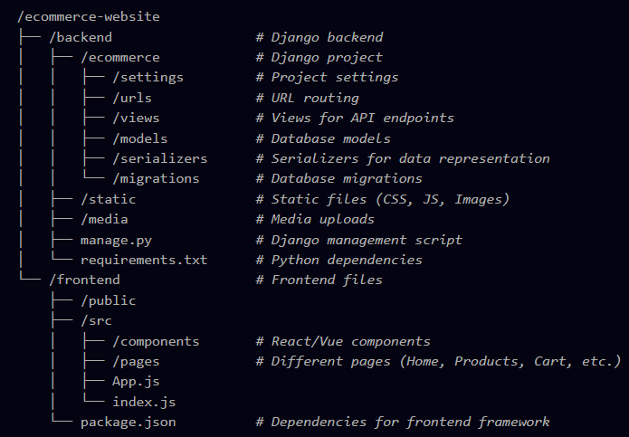

Features to be Implemented
- User Authentication:
- One can register an account using an email and password or log in if a user has an account.
- A user is able to manage his profile, change account information, look at the history of placed orders, and perform address management.
- Password Reset: Add a password reset feature that enables the recovery of an account by email.

- Product Catalog:
- Product Listing: List several products with the name, price, description, and images.
- Product Filtering and Sorting: Allow filtering of products by categories, prices, and ratings and sorting them by relevance, prices, or popularity.
- Product Search: Allow a search bar for users to be able to find products fast.

- Product Details:
- Detailed product pages with many images, specifications, reviews, and a section showing related products.
- Add to Cart: Customer will be able to select the quantity and variants-for example, size, color-and add the product to his or her shopping cart.

- Shopping Cart:
- View Cart: Customer can view items added to their cart, modify the item quantity, or remove the item.
- Cart Persistence: Session management shall ensure the persistence of carts across sessions for the logged-in customer.

- Checkout Process:
- Shipping Details: Store shipping address and contact details for the user.
- Payment Integration: Integrate Stripe or PayPal to handle secure payment processing and credit/debit card transactions.
- Order Summary: Summary of the order should be shown once confirming the purchase, including items, shipping costs, and total amount.

- Order Management:
- Order Confirmation: Send an email notification for a successful order, including details and/or tracking numbers where applicable.
- Order Tracking: Each user will be able to view the status of their orders within their account dashboard.
- Admin Dashboard: The administration panel will manage orders, products, and user accounts.

- Rating and Review by User:
- Users can review and rate the product they have purchased to help other customers decide more logically.

- Responsiveness:
- The website should be fully responsive to give the same feel and view for desktop, tablet, and smartphone users using CSS3 or Bootstrap.

- Security Features:
- CSRF Protection: Cross-Site Request Forgery protection in forms for security against attacks.
- SQL Injection Prevention: Use Django ORM to avoid any SQL injection attacks.
- HTTPS/SSL: Ensure that data is being sent securely, especially during the payment process.

- Performance Optimization:
- Caching: Implement caching for the most frequently visited pages such as product listing pages.
- Image Optimization: Compress and optimize images for faster loading.
- Pagination: Implement pagination in product listing for better performance in loading.

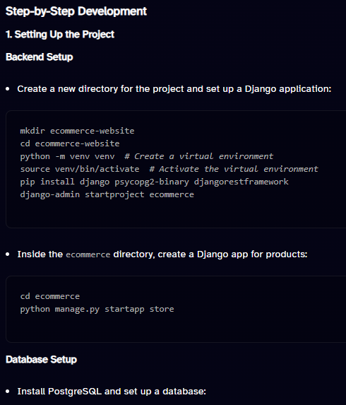
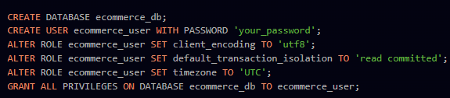
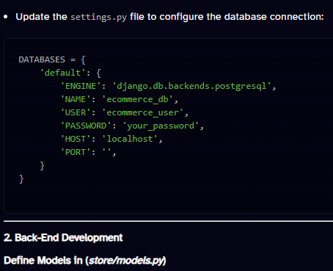

- Create Serializers in (store/serializers.py)
- Create Views in (store/views.py)
- Define URL Routes in (ecommerce/urls.py)

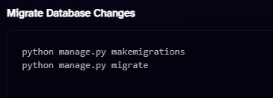
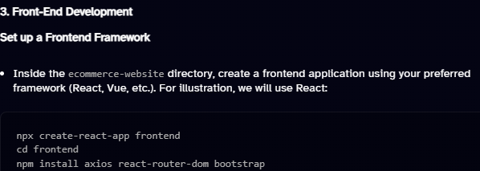
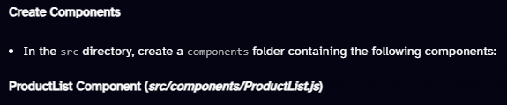
App Component (src/App.js)
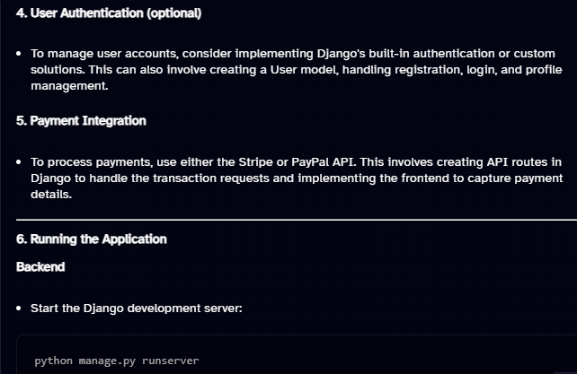
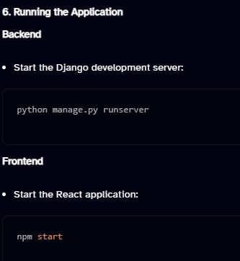
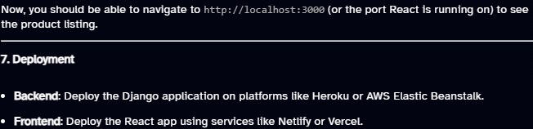

Challenges Faced
- A user-friendly UI had to be created which could efficiently handle all complicated functionalities like filtering, sorting, and checkout without cluttering the website.
- Industry-standard secure payment methods without revealing any privacy-sensitive user information.
- Deal with large datasets in the product catalog and ensure efficient querying on it using PostgreSQL.
- Secure authentication of users and effective session management.

Future Plans
- Wishlist Feature: Allow users to save products they're interested in for future purchases.
- Discount Codes and Promotions: There will be a feature enabling customers to make purchases with the use of discount codes upon checkout.
- Stock Management: Put in place an advanced stock management system wherein inventories would be updated automatically upon a product purchase.
- Advanced Analytics: Integrate analytics regarding sales and user behavior for tracking performances by admins.
- Support for Multi-language and Multi-currency: Allow the platform to scale up to support more languages and currencies for customers across the globe.

Conclusion
The E-commerce Website project testifies to the ability to perform construction of complex applications by means of modern approaches in web development. It integrates back-end and front-end technologies, emphasizes user account management, and provides a responsive UI. Working on this project enhances skills in full-stack development and familiarizes one with workflows necessary for constructing production-grade applications.

